1. Exploratory Data Analysis (EDA)
1.1 Dataset Understanding
The first stage of the project was Exploratory Data Analysis (EDA) on the IBM Telco Customer Churn dataset.
The purpose of EDA was to understand:
- The structure of the dataset
- Customer characteristics
- Numerical and categorical variables
- Customer churn distribution
- Relationships between variables
- Possible patterns related to customer churn
- Missing values and outliers
1.2 Churn Distribution
We first analyzed the distribution of the target variable Churn.
The target contains two categories:
- No → Customer did not churn
- Yes → Customer churned
The analysis showed that the dataset contains more customers who did not churn than customers who churned.
The overall churn rate was approximately 26.54%.
This indicates that churn is an important business problem and that the target classes are not perfectly balanced.
1.3 Numerical Feature Analysis
We analyzed the distributions of the main numerical variables:
- tenure
- MonthlyCharges
- TotalCharges
Tenure
tenure represents the number of months a customer has stayed with the company.
It helps us understand the relationship between customer lifetime and churn behavior.
Monthly Charges
MonthlyCharges represents the customer's monthly service charge.
It helps identify whether customers with higher monthly costs show different churn behavior.
Total Charges
TotalCharges represents the total amount charged to the customer during their relationship with the company.
It is related to both customer tenure and monthly charges.
1.4 Categorical Feature Analysis
We also analyzed categorical variables such as:
- Gender
- Partner
- Dependents
- Internet Service
- Contract
- Payment Method
- Online Security
- Tech Support
- Streaming Services
This helped us understand the composition of the customer base and identify categories that may be associated with churn.
1.5 Churn vs Numerical Features
We compared churn behavior against numerical variables such as:
- tenure
- MonthlyCharges
- TotalCharges
This helped us identify whether customer duration and billing-related variables showed differences between churned and non-churned customers.
1.6 Contract vs Churn
One of the important EDA analyses was the relationship between Contract and Churn.
The churn distribution was:
Contract | No Churn | Churn
Month-to-month | 57.29% | 42.71%
One year | 88.73% | 11.27%
Two year | 97.17% | 2.83%
This showed a clear difference in churn distribution across contract types, making Contract an important feature to consider in later analysis and modelling.

1.7 Correlation Analysis
We performed correlation analysis on numerical variables.
Important correlations observed were:
Variables | Correlation
Tenure - TotalCharges | 0.83
MonthlyCharges - TotalCharges | 0.65
Tenure - MonthlyCharges | 0.25
SeniorCitizen - MonthlyCharges | 0.22
SeniorCitizen - TotalCharges | 0.10
SeniorCitizen tenure | 0.017
The strongest relationship was between tenure and TotalCharges (0.83).
This is reasonable because customers who stay longer generally accumulate higher total charges.
1.8 Outlier Analysis
We checked the main numerical variables for outliers:
- tenure
- MonthlyCharges
- TotalCharges
No significant outliers were identified in these variables during the analysis.
Therefore, no outlier-removal step was required at this stage.
1.9 EDA Conclusion
From EDA, we identified several important observations:
- The dataset has approximately 26.54% churn.
- Contract type has a strong relationship with churn distribution.
- tenure and TotalCharges have a strong positive correlation.
- MonthlyCharges and TotalCharges are also positively correlated.
- No significant numerical outliers were found.
- Several customer service and contract-related features appeared useful for further analysis.

2. Data Cleaning and Preprocessing

2.1 Data Cleaning
After completing EDA, the dataset was cleaned before performing SQL analysis and machine learning.
The TotalCharges column contained some values that were not recognized as numerical values. Therefore, the column was converted into a numeric datatype.
df['TotalCharges'] = pd.to_numeric(
df['TotalCharges'],
errors='coerce'
)
The conversion produced 11 missing values in TotalCharges. These records corresponded to customers with zero tenure. Since these customers had not accumulated any charges, the missing values were replaced with 0.
df['TotalCharges'] = df['TotalCharges'].fillna(0)
2.2 Removing Unnecessary Column
The customerID column was removed from the modelling dataset because it is an identifier and does not provide predictive information about customer churn.
df = df.drop('customerID', axis=1)
2.3 Target Variable
The target variable was Churn.
It was converted from categorical values into numerical values:
- No → 0
- Yes → 1
y = df['Churn'].map({
'No': 0,
'Yes': 1
})
This conversion allowed the machine-learning algorithms to work with the target variable.

2.4 Train-Test Split
The dataset was divided into training and testing sets using an 80:20 split.
X_train, X_test, y_train, y_test = train_test_split(
X,
y,
test_size=0.2,
random_state=42,
stratify=y
)
The resulting datasets were:
- Training samples: 5,634
- Testing samples: 1,409
stratify=y was used to maintain a similar churn/non-churn distribution in both training and testing datasets.
2.5 Categorical Encoding
Categorical variables were converted into numerical values using One-Hot Encoding.
encoder = OneHotEncoder(
drop='first',
handle_unknown='ignore',
sparse_output=False
)
drop='first' was used to avoid redundant dummy variables, while handle_unknown='ignore' ensures that unseen categories in test/new customer data do not cause an error.
2.6 Numerical Scaling
The numerical variables were standardized using StandardScaler.
scaler = StandardScaler()

X_train_num = scaler.fit_transform(
X_train[numeric_cols]
)

X_test_num = scaler.transform(
X_test[numeric_cols]
)
The scaler was fitted only on the training data and then applied to the test data to avoid data leakage.
2.7 Final Preprocessed Data
The scaled numerical features and encoded categorical features were combined using NumPy.
X_train = np.hstack([
X_train_num,
X_train_cat
])

X_test = np.hstack([
X_test_num,
X_test_cat
])
The initial preprocessed feature matrix contained 30 features.
2.8 Conclusion
The data-cleaning and preprocessing stage prepared the dataset for feature engineering and machine-learning modelling by:
- Handling invalid numerical values
- Handling missing TotalCharges
- Removing the customer identifier
- Encoding the target variable
- Splitting the dataset
- Encoding categorical features
- Scaling numerical features

3. SQL Analysis
After data cleaning, the dataset was stored in a SQLite database to perform structured customer analysis using SQL queries.
3.1 Creating the Database
The cleaned customer dataset was stored in a SQLite table named customers.
conn = sqlite3.connect('customer_intelligence.db')

df.to_sql( 'customers', conn, if_exists='replace', index=False)
This allowed customer information to be analyzed using SQL queries.
3.2 Customer Count
The first query was used to determine the total number of customers.
SELECT COUNT(*) AS total_customers
FROM customers;
This provided the overall size of the customer base.
3.3 Total Churned Customers
The number of customers who had churned was calculated using:
SELECT COUNT(*) AS churned_customers
FROM customers
WHERE Churn = 'Yes';
3.4 Churn Rate
The overall churn rate was calculated as:
SELECT
ROUND(
SUM(CASE WHEN Churn = 'Yes' THEN 1 ELSE 0 END)
* 100.0 / COUNT(*),
2
) AS churn_rate
FROM customers;
The resulting churn rate was approximately 26.54%.
3.5 Churn by Contract
Contract type was analyzed to understand differences in churn:
SELECT
Contract,
COUNT(*) AS total_customers,
SUM(CASE WHEN Churn = 'Yes' THEN 1 ELSE 0 END)
AS churned_customers
FROM customers
GROUP BY Contract;
This analysis showed that churn behavior differed substantially across contract types.
3.6 Churn by Payment Method
Payment methods were also analyzed:
SELECT
PaymentMethod,
COUNT(*) AS total_customers,
SUM(CASE WHEN Churn = 'Yes' THEN 1 ELSE 0 END)
AS churned_customers
FROM customers
GROUP BY PaymentMethod;
This helped identify differences in churn across payment methods.
3.7 Customer Segmentation
Customers were grouped according to their internet service:
SELECT
InternetService,
COUNT(*) AS total_customers,
SUM(
CASE WHEN Churn = 'Yes' THEN 1 ELSE 0 END
) AS churned_customers,
ROUND(
SUM(CASE WHEN Churn = 'Yes' THEN 1 ELSE 0 END)
* 100.0 / COUNT(*),
2
) AS churn_rate
FROM customers
GROUP BY InternetService
ORDER BY total_customers DESC;
This provided the number of customers, churned customers, and churn rate for each internet-service category.

3.8 Revenue Analysis
Monthly revenue-related information was also analyzed:
SELECT
ROUND(SUM(MonthlyCharges), 2)
AS total_monthly_revenue,
ROUND(AVG(MonthlyCharges), 2)
AS average_monthly_revenue_per_customer
FROM customers;
This helped understand the overall monthly revenue generated by the customer base.
3.9 High-Value Customers
Customers with the highest total charges were identified using:
SELECT
customerID,
Contract,
tenure,
MonthlyCharges,
TotalCharges
FROM customers
ORDER BY TotalCharges DESC
LIMIT 10;
3.10 Long-Tenure Customers
Long-term customers were identified using:
SELECT
customerID,
Contract,
tenure,
MonthlyCharges,
TotalCharges,
Churn
FROM customers
ORDER BY tenure DESC
LIMIT 10;
3.11 SQL Analysis Conclusion
The SQL stage was used to analyze:
- Overall customer count
- Churned customers
- Churn rate
- Churn by contract
- Churn by payment method
- Churn by internet service
- Revenue
- High-value customers
- Long-tenure customers
- Customer segments
The results provided structured insights that were later used alongside machine-learning analysis

4. Feature Engineering
After SQL analysis, feature engineering was performed to create additional variables that could provide more useful information to the machine-learning models.
The new features were created from existing customer attributes such as tenure, services, charges, contract type, and payment method.
4.1 Tenure-Based Features
Customers were grouped according to their tenure:
df['tenure_group'] = pd.cut(
df['tenure'],
bins=[-1, 12, 24, 48, 72],
labels=['New', 'Short-term', 'Mid-term', 'Long-term']
)
Two additional binary features were created:
df['is_new_customer'] = (
df['tenure'] <= 12
).astype(int)

df['is_long_term_customer'] = (
df['tenure'] > 48
).astype(int)
These features identify newly joined and long-term customers.
4.2 Service-Based Features
The number of subscribed services was calculated:
service_cols = [
'PhoneService', 'MultipleLines',
'OnlineSecurity', 'OnlineBackup',
'DeviceProtection', 'TechSupport',
'StreamingTV', 'StreamingMovies'
]

df['num_subscribed_services'] = (
df[service_cols] == 'Yes'
).sum(axis=1)
Optional services were also counted separately:
optional_service_cols = [
'OnlineSecurity', 'OnlineBackup',
'DeviceProtection', 'TechSupport',
'StreamingTV', 'StreamingMovies'
]

df['num_optional_services'] = (
df[optional_service_cols] == 'Yes'
).sum(axis=1)
Another feature was created to indicate whether the customer has internet service:
df['has_internet_service'] = (
df['InternetService'] != 'No'
).astype(int)
4.3 Charge-Based Features
Monthly charges were divided into groups:
df['monthly_charge_group'] = pd.cut(
df['MonthlyCharges'],
bins=[0, 35, 70, float('inf')],
labels=['Low', 'Medium', 'High']
)
Total charges were also categorized:
df['total_charge_group'] = pd.cut(
df['TotalCharges'],
bins=[-1, 1000, 3000, 6000, float('inf')],
labels=['Low', 'Medium', 'High', 'Very High']
)
A charge-to-tenure ratio was created to represent the relationship between total charges and customer tenure:
df['charge_to_tenure_ratio'] = (
df['TotalCharges'] /
df['tenure'].replace(0, np.nan)
).fillna(0)
4.4 Risk-Based Features
A contract risk feature was created for month-to-month contracts:
df['contract_risk'] = (
df['Contract'] == 'Month-to-month'
).astype(int)
An additional payment-method feature identified electronic-check customers:
df['payment_method_risk'] = (
df['PaymentMethod'] == 'Electronic check'
).astype(int)
A service-combination feature was created for customers without both online security and technical support:
df['service_combination_risk'] = (
(df['OnlineSecurity'] == 'No') &
(df['TechSupport'] == 'No')
).astype(int)
Finally, a combined high-value/high-risk feature was created:
df['high_value_high_risk'] = (
(df['TotalCharges'] >= 6000) &
(df['contract_risk'] == 1)
).astype(int)
4.5 Feature Engineering Outcome
Feature engineering expanded the information available to the machine-learning models by converting existing customer attributes into additional numerical and categorical features.
The engineered dataset was then used for the baseline machine-learning models.

5. Machine Learning Model Development
After feature engineering, the prepared customer dataset was used to develop machine-learning models for customer churn prediction.
The objective was to compare multiple classification algorithms and identify a suitable model for predicting whether a customer is likely to churn.
5.1 Train-Test Data
The target variable was converted into binary form:
- 0 → No Churn
- 1 → Churn
The dataset was divided into:
- 80% training data
- 20% testing data
Stratified splitting was used to maintain the churn distribution in both datasets.
5.2 Models Used
Several classification algorithms were trained and evaluated:
- Logistic Regression
- Decision Tree
- K-Nearest Neighbors (KNN)
- Random Forest
- Gradient Boosting
- XGBoost
These models were compared using multiple evaluation metrics rather than relying only on accuracy.
5.3 Evaluation Metrics
The following metrics were used:
- Accuracy – overall proportion of correctly classified customers.
- Precision – proportion of predicted churn customers that actually churned.
- Recall – proportion of actual churn customers correctly identified.
- F1-score – balance between precision and recall.
- ROC-AUC – measures the model's ability to distinguish between churn and non-churn customers.
- PR-AUC – evaluates precision-recall performance, particularly useful when the target classes are imbalanced.

5.4 Baseline Model Results
The baseline models produced the following results:
Model | Accuracy | Precision | Recall | F1 | ROC-AUC | PR-AUC
Logistic Regression | 0.8020 | 0.6599 | 0.5241 | 0.5842 | 0.8435 | 0.6416
Decision Tree | 0.7246 | 0.4826 | 0.5187 | 0.5000 | 0.6586 | 0.3781
KNN | 0.7764 | 0.5865 | 0.5348 | 0.5594 | 0.7805 | 0.5217
Random Forest | 0.7821 | 0.6057 | 0.5134 | 0.5557 | 0.8240 | 0.6122
Gradient Boosting | 0.8048 | 0.6689 | 0.5241 | 0.5877 | 0.8450 | 0.6631
XGBoost | 0.7743 | 0.5903 | 0.4893 | 0.5351 | 0.8192 | 0.6078
Among the baseline experiments, Gradient Boosting produced the strongest overall baseline results based on the evaluation metrics, with an F1-score of approximately 0.588, ROC-AUC of 0.845, and PR-AUC of 0.663.
5.5 Baseline Model Selection
Gradient Boosting was selected for further experimentation.
The next stage focused on improving its ability to identify churn customers, particularly because the dataset contains fewer churned customers than non-churned customers.
This led to the use of class weighting, threshold analysis, and hyperparameter tuning.

6. Model Improvement and Final Model Selection
After comparing the baseline models, Gradient Boosting was selected for further improvement.
The main focus was to improve the model's ability to identify customers who are likely to churn.
6.1 Class Weighting
The churn dataset is imbalanced because there are fewer churned customers than non-churned customers.
To give more importance to the minority churn class, balanced sample weights were calculated:
from sklearn.utils.class_weight import compute_sample_weight
sample_weights = compute_sample_weight(class_weight='balanced', y=y_train)
The weighted Gradient Boosting model improved churn detection.
The results were:
Metric | Weighted Gradient Boosting
Accuracy | 0.7466
Precision | 0.5149
Recall | 0.7861
F1-score | 0.6222
ROC-AUC | 0.8417
PR-AUC | 0.6595
The important change was the increase in recall, meaning the model identified a larger proportion of actual churn customers.
6.2 Probability Threshold Analysis
The default classification threshold of 0.50 was evaluated along with other thresholds.
Threshold | Precision | Recall | F1-score
0.30 | 0.436 | 0.912 | 0.590
0.40 | 0.476 | 0.845 | 0.609
0.50 | 0.515 | 0.786 | 0.622
0.60 | 0.565 | 0.690 | 0.621
0.70 | 0.627 | 0.567 | 0.596
Based on the tested thresholds, 0.50 was retained because it produced the highest F1-score among the evaluated thresholds.
6.3 Hyperparameter Tuning
RandomizedSearchCV was used to search for better Gradient Boosting parameters.
The best parameters found were:
n_estimators = 100
min_samples_split = 10
max_depth = 3
learning_rate = 0.1
However, the cross-validation F1-score obtained during tuning was approximately 0.580, compared with approximately 0.582 for the original Gradient Boosting model.
Therefore, the hyperparameter-tuned model did not provide an improvement over the original model.
6.4 Feature Importance
Feature importance was analyzed to identify the features contributing most to the Gradient Boosting model.
The top features included:
- contract_risk
- service_combination_risk
- tenure
- InternetService_Fiber optic
- MonthlyCharges
- TotalCharges
- charge_to_tenure_ratio
- payment_method_risk
- Contract_Two year
- PaperlessBilling_Yes
- PaymentMethod_Electronic check
- StreamingMovies_Yes
- Contract_One year
- Dependents_Yes
- OnlineBackup_Yes
The top 15 features were selected for the final modelling stage.
6.5 Final Gradient Boosting Model
A weighted Gradient Boosting model was trained using the selected top 15 features.
The final model achieved:
Metric | Final Model
Accuracy | 0.7445
Precision | 0.5121
Recall | 0.7914
F1-score | 0.6218
ROC-AUC | 0.8411
PR-AUC | 0.6583
The model was saved for later integration with the Flask application.
joblib.dump( gb_top15, "models/churn_model.pkl")
joblib.dump( top_15_features, "models/top_15_features.pkl")
joblib.dump( top_15_indices,"models/top_15_indices.pkl")
The preprocessing objects were also saved:
joblib.dump(encoder, "models/encoder.pkl")
joblib.dump(scaler, "models/scaler.pkl")
6.6 Conclusion
The model improvement stage included:
- Class weighting
- Probability threshold analysis
- Hyperparameter tuning
- Feature importance analysis
- Top-15 feature selection
- Final model training
- Saving the trained model and preprocessing objects
The resulting Gradient Boosting model was used as the churn prediction component in the later SHAP, integration, agent, and Flask stages.

7. Artificial Neural Network (ANN) Model
After developing the Gradient Boosting model, an Artificial Neural Network (ANN) was implemented as an additional machine-learning approach for churn prediction.
7.1 ANN Architecture
The ANN was designed using a simple feed-forward architecture:
Input Layer
↓
Dense Layer — 64 neurons, ReLU
↓
Dropout — 30%
↓
Dense Layer — 32 neurons, ReLU
↓
Dropout — 30%
↓
Output Layer — 1 neuron, Sigmoid
The input layer receives the 15 selected features from the feature-selection stage.
7.2 Model Configuration
The ANN architecture was implemented using:
model = Sequential([
Dense(64, activation='relu', input_shape=(15,)),
Dropout(0.3),
Dense(32, activation='relu'),
Dropout(0.3),
Dense(1, activation='sigmoid')
])
The model contains approximately 3,137 trainable parameters.
The model was trained for 10 epochs.
7.3 Activation Functions
ReLU
The hidden layers use the ReLU (Rectified Linear Unit) activation function.
It allows the network to learn non-linear relationships between the input features.
Sigmoid
The output layer uses Sigmoid activation.
Since churn is a binary classification problem, the sigmoid output represents the probability of the customer belonging to the churn class.
7.4 Dropout
A dropout rate of 0.3 was used after each hidden layer.
Dropout randomly disables a portion of neurons during training, helping reduce the possibility of overfitting.
7.5 ANN Results
The ANN was evaluated using the same classification metrics used for the other models.
Metric  Metrics | Results
Accuracy | 0.7935
Precision | 0.6231
Recall | 0.5615
F1-score | 0.5907
ROC-AUC | 0.8372
PR-AUC | 0.6425
7.6 Comparison with Final Gradient Boosting Model
The ANN provided another modelling approach, but the weighted Gradient Boosting model with the selected 15 features remained the model used for the later integration stages.
The ANN was therefore treated as an additional model experiment rather than replacing the selected Gradient Boosting model.
7.7 Conclusion
The ANN demonstrated that a neural-network approach can also be applied to the churn prediction problem. The experiment provided a comparison between traditional ensemble-based machine learning and a neural-network model.
The project then moved to Explainable AI using SHAP to understand why individual customers receive their churn predictions.

8. SHAP Explainable AI
After developing the churn prediction models, SHAP (SHapley Additive exPlanations) was used to explain the predictions made by the selected Gradient Boosting model.
The purpose of this stage was to understand which features contributed to an individual customer's churn prediction.
8.1 Why SHAP Was Used
A machine-learning model can predict whether a customer is likely to churn, but the prediction alone does not explain why the customer was classified that way.
SHAP provides feature-level explanations by showing how each feature contributes to the model's output.
For this project:
- Positive SHAP value → pushes the prediction toward churn.
- Negative SHAP value → pushes the prediction away from churn.
SHAP values therefore provide an interpretable explanation of the model's decision.
8.2 SHAP Implementation
The selected Gradient Boosting model was used with TreeExplainer.
explainer = shap.TreeExplainer(model)

customer_shap = explainer(
customer_top15
)
The SHAP values for the customer were extracted using:
shap_values_customer = customer_shap.values[0]
The values were then associated with the selected top 15 features.
8.3 Individual Customer Explanation
For one customer, the SHAP analysis produced contributions such as:
Feature | SHAP value | Effect
contract_risk | -0.9421 | Away from churn
service_combination_risk | -0.4626 | Away from churn
tenure | -1.2620 | Away from churn
InternetService_Fiber optic | 0.0889 | Toward churn
MonthlyCharges | -0.2486 | Away from churn
TotalCharges | 0.2775 | Toward churn
charge_to_tenure_ratio | 0.2049 | Toward churn
payment_method_risk | 0.0178 | Toward churn
The signs of the SHAP values indicate the direction in which each feature influenced the model prediction.
For example, a positive SHAP value indicates that the feature contributed toward the churn prediction, while a negative value contributed in the opposite direction.
8.4 Global Feature Importance
SHAP was also used to understand the features that were generally influential across the model.
The strongest global features included:
- contract_risk
- tenure
- service_combination_risk
- MonthlyCharges
- InternetService_Fiber optic
This provided a model-based view of which features were important across customer predictions.
8.5 SHAP in the Final Application
The SHAP explanation was later integrated into the customer prediction workflow.
The application can therefore provide:
Customer ID
↓
Customer Profile
↓
Churn Prediction
↓
SHAP Explanation
This allows the system to provide not only a churn prediction but also the important model factors behind that prediction.
8.6 Conclusion
SHAP added an Explainable AI layer to the churn prediction system.
The final workflow therefore became:
Customer Data → ML Prediction → SHAP Explanation
This explanation was later integrated with the SQL, RAG, LLM, tool-calling, and Flask application components.

9. NLP and Text Classification
After completing the churn prediction and SHAP analysis, Natural Language Processing (NLP) was applied to the customer support ticket dataset.
The purpose was to process customer-support text and determine whether the ticket information could be used for automatic text classification.
9.1 Combining Text Fields
The dataset contained two important text fields:
- Ticket Subject
- Ticket Description
These fields were combined to create a single text input for NLP processing.
df['text'] = (
df['Ticket Subject'].fillna('') + ' ' +
df['Ticket Description'].fillna('')
)
Combining both fields provided more information than using the ticket subject alone.
9.2 Text Cleaning
The text was cleaned before converting it into numerical features.
The preprocessing included:
- Converting text to lowercase
- Replacing underscores with spaces
- Removing non-alphabetic characters
- Removing extra whitespace
- Tokenizing the text
- Removing stopwords
- Removing selected domain-specific words
The custom stopword set included:
product
purchased
This preprocessing reduced unnecessary words and prepared the text for feature extraction.

9.3 TF-IDF Feature Extraction
TF-IDF (Term Frequency–Inverse Document Frequency) was used to convert the cleaned ticket text into numerical features.
The configuration used:
- Maximum features: 5,000
- N-gram range: unigram + bigram
This allowed the model to capture both individual words and two-word combinations.
For example:
"payment failed"
could be represented using:
payment
failed
payment failed
9.4 Train-Test Separation
The ticket dataset was divided into training and testing data before fitting the TF-IDF vectorizer.
This prevents information from the test dataset from influencing the feature extraction process.
The TF-IDF vectorizer was fitted on the training text and then used to transform both training and testing text.
9.5 Text Classification
Logistic Regression was used as a text-classification model with the TF-IDF features.
The classification task involved five ticket categories.
The model achieved an accuracy of approximately 19.66%.
Additional experiments were performed using:
- Ticket subject only
- Naive Bayes
The subject-only experiment achieved approximately 18.18%, while Naive Bayes achieved approximately 19.48%.
9.6 Interpretation
The classification results were close to the expected performance of random selection for five classes.
This indicated that the available ticket text and labels did not provide strong enough information for reliable automatic classification.
Therefore, the NLP classification experiment was documented as an exploratory component rather than being used as the main intelligence mechanism of the final platform.
9.7 NLP Workflow
The NLP pipeline can be summarized as:
Customer Support Tickets
↓
Subject + Description
↓
Text Cleaning
↓
Tokenization
↓
Stopword Removal
↓
TF-IDF
↓
Text Classification
↓
Model Evaluation
9.8 Conclusion
The NLP stage demonstrated the process of converting unstructured customer-support text into machine-readable features and applying a classification model.
Although the classification performance was limited, the processed ticket data was later used for text embeddings and semantic search, which formed the basis for the project's RAG component.

10. Text Embeddings and FAISS Semantic Search
10.1 Text Embeddings
Text embeddings were used to convert customer support ticket text into numerical vector representations. Unlike TF-IDF, which mainly represents the importance of individual words, embeddings capture the semantic meaning of the text.
For this project, the all-MiniLM-L6-v2 Sentence Transformer model was used to generate embeddings.
The generated embedding for a ticket had 384 dimensions.
Why we used embeddings
Embeddings allow us to compare texts based on their meaning rather than only matching exact words. This is important for the semantic search and RAG components of the project.
How it was done
The embedding model was loaded and used to convert ticket text into vectors:
from sentence_transformers import SentenceTransformer

embedding_model = SentenceTransformer("all-MiniLM-L6-v2")

embeddings = embedding_model.encode(ticket_text)
The resulting embeddings had the shape:
(8469, 384)
This means that 8,469 ticket records were represented as vectors, with each vector containing 384 numerical values.
10.2 FAISS Semantic Search
The generated embeddings were stored in a FAISS index to enable fast similarity searching.
FAISS (Facebook AI Similarity Search) was used because the project requires a local, lightweight vector search solution without using a cloud-based vector database.
import faiss

dimension = embeddings.shape[1]

index = faiss.IndexFlatL2(dimension)
index.add(embeddings.astype("float32"))
The resulting FAISS index contained:
8469 vectors
384 dimensions
The index was saved locally so that it could be reused without generating all embeddings again.
10.3 Semantic Search Process
When a new query is entered, the query is first converted into an embedding using the same embedding model.
The FAISS index then searches for the most similar vectors.
query_vector = embedding_model.encode(
["My product is not working"]
).astype("float32")

distances, indices = index.search(query_vector, 5)
The search returns the most similar ticket records along with their similarity distances.
For example, the query:
My product is not working
returned the top five matching ticket records.
10.4 Result and Interpretation
The embedding and FAISS pipeline successfully converted the support tickets into searchable semantic vectors.
The important difference from keyword search is that the system can retrieve tickets with similar meaning, even when the exact words in the query and stored ticket are different.
The FAISS index was later used as part of the project's RAG pipeline, where retrieved information is provided as context to the local LLM.
Conclusion
Text embeddings provided the semantic representation required for intelligent search, while FAISS provided efficient local vector retrieval. This formed the foundation for the semantic search and RAG components of the Customer Intelligence Platform.

11. Knowledge Base Creation
11.1 Knowledge Base
After implementing semantic search for customer support tickets, we created a separate knowledge base for business and support information.
The knowledge base contains 104 small documents covering information that can be useful when answering customer-related questions.
Examples include information related to:
- Subscription cancellation
- Customer support
- Product/service information
- Business policies
11.2 Document Chunking
The knowledge-base documents were divided into smaller text chunks before creating embeddings.
A chunk size of 50 words was used.
Since the documents were already small, each document remained within a single chunk.
Therefore:
Documents = 104
Chunks = 104
This makes the information easier to retrieve during semantic search.
11.3 Embedding the Knowledge Base
The same all-MiniLM-L6-v2 embedding model was used to convert the knowledge-base chunks into numerical vectors.
The generated embeddings had:
104 vectors
384 dimensions
These vectors were then added to a separate FAISS index.
kb_index = faiss.IndexFlatL2(384)
kb_index.add(kb_embeddings.astype("float32"))
The following files were saved:
kb_faiss.index
kb_chunks.pkl
knowledge_base.csv

11.4 Knowledge Base Retrieval
When a user asks a question, the question is converted into an embedding and searched against the knowledge-base FAISS index.
For example:
How can I cancel my subscription?
The system retrieves the most semantically similar knowledge-base records.
The retrieved records are then converted into a text context that can be provided to the local LLM.
11.5 Result and Interpretation
The knowledge base successfully provided a local source of business/support information for the RAG pipeline.
During testing, cancellation-related queries retrieved multiple similar cancellation records. This was due to duplicate or highly similar information in the knowledge base rather than an issue with FAISS itself.
The knowledge base therefore acts as the unstructured information source of the Customer Intelligence Platform.
Conclusion
The knowledge base and FAISS index provide the information required for the project's RAG system. The next stage is to combine this retrieved knowledge with the local LLM to generate responses.

12. Retrieval-Augmented Generation (RAG)
12.1 RAG Implementation
Retrieval-Augmented Generation (RAG) was implemented to connect the project's semantic search system with the local language model.
The purpose of RAG is to retrieve relevant information from the knowledge base first and then provide that information as context to the LLM.
The basic workflow is:
User Question
↓
Create Query Embedding
↓
FAISS Semantic Search
↓
Retrieve Relevant Knowledge
↓
Build Context
↓
Local LLM
↓
Generate Response
12.2 Knowledge Retrieval
For every user question, the question is converted into an embedding using all-MiniLM-L6-v2.
The embedding is then searched against the knowledge-base FAISS index.
def retrieve_knowledge(query, top_k=5):
query_vector = embedding_model.encode([query]).astype("float32")
distances, indices = kb_index.search(query_vector, top_k)

results = kb_chunks_df.iloc[indices[0]]
return results
The system retrieves the top five semantically similar knowledge-base records.

12.3 Building the RAG Context
The retrieved records are combined into a text context containing the category, title, and information.
def build_rag_context(rag_results):
context = ""

for _, row in rag_results.iterrows():
context += f"""
Category: {row['category']}
Title: {row['title']}
Information: {row['text']}
"""

return context
This context is then available for the LLM when generating its response.
12.4 Example
For a question such as:
How can I cancel my subscription?
the system performs:
- Convert the question into an embedding.
- Search the knowledge-base FAISS index.
- Retrieve relevant cancellation information.
- Combine the retrieved records into context.
- Provide the context to the local LLM.
- Generate the final response.
12.5 Result and Interpretation
The RAG pipeline successfully connected the knowledge base, embeddings, FAISS retrieval, and local LLM.
This allows the LLM to use project-specific information instead of relying only on its pretrained knowledge.
The system was designed to keep retrieval local, following the project requirement of avoiding paid APIs and cloud-based vector databases.
13. Local LLM Integration
13.1 Local Language Model
After implementing RAG, the next step was to integrate a local instruction-tuned Large Language Model (LLM).
The project uses:
Qwen/Qwen2.5-1.5B-Instruct
The model was selected to keep the system local and lightweight compared with larger LLMs.
13.2 Why We Used a Local LLM
The project requirements specify that the system should avoid paid APIs and cloud-based LLM services.
Therefore, the LLM was loaded locally using the Transformers library.
from transformers import AutoTokenizer, AutoModelForCausalLM

model_name = "Qwen/Qwen2.5-1.5B-Instruct"

tokenizer = AutoTokenizer.from_pretrained(model_name)

llm = AutoModelForCausalLM.from_pretrained(
model_name,
torch_dtype="auto"
)
The tokenizer converts the input text into tokens, while the LLM generates the response.
13.3 Connecting RAG with the LLM
The retrieved knowledge from the RAG system was included in the prompt sent to the LLM.
The overall process became:
User Question
↓
Embedding Model
↓
FAISS Knowledge Search
↓
Retrieved Context
↓
Prompt + Context
↓
Qwen 1.5B LLM
↓
Generated Response
This allows the LLM to generate responses using the information retrieved from the project's knowledge base.
13.4 Prompt-Based Response Generation
A prompt was created containing the customer information, model information, retrieved support knowledge, and the user's question.
For example:
prompt = f"""
Answer the question using the information provided below.

Customer ID: {customer_id}

Churn probability:
{churn_probability}

Model explanation:
{shap_explanation}

Support information:
{knowledge_base}

Question:
{question}

Answer:
"""
The prompt was then tokenized and passed to the LLM:
inputs = tokenizer(prompt, return_tensors="pt")

outputs = llm.generate(
**inputs,
max_new_tokens=150
)

response = tokenizer.decode(
outputs[0],
skip_special_tokens=True
)
13.5 Result and Interpretation
The local LLM successfully generated natural-language responses from the provided context.
During testing, it was observed that the 1.5B model could sometimes paraphrase or interpret SHAP feature names incorrectly.
Therefore, the system does not depend on the LLM to calculate or independently interpret the underlying ML results.
Instead:
- Python/ML provides the actual churn prediction.
- SHAP provides the model explanation.
- RAG provides business/support knowledge.
- LLM converts the available information into a natural-language response.
Conclusion
The local Qwen LLM completed the project's local GenAI generation layer while maintaining the requirement of avoiding paid external LLM APIs.

14. Prompt Engineering
14.1 Prompt Engineering
Prompt engineering was used to control how the local LLM receives and processes information.
Since the project combines multiple sources such as customer information, churn prediction, SHAP explanations, and knowledge-base results, the prompt was designed to clearly separate these inputs.
The objective was to make the LLM generate responses using the information provided by the system rather than independently calculating ML results.
14.2 Information Provided to the LLM
The prompt can contain:
- Customer ID
- Churn probability
- Model explanation
- Retrieved support/knowledge-base information
- User's question
For example:
prompt = f"""
Answer the question using the information provided below.
Customer ID: {customer_id}
Churn probability:
{churn_probability}
Model explanation:
{shap_explanation}
Support information:
{knowledge_base}
Question:
{question}
Answer:
"""
This gives the LLM the required context before generating the answer.
14.3 Question Understanding
Prompt engineering was also used to determine which information was required for a customer's question.
The system provides the LLM with four possible information sources:
customer_profile
churn_prediction
shap_explanation
knowledge_base
The model is instructed to identify the required source based on the question.
For example:
Customer details → customer_profile

Churn/risk → churn_prediction

Reason for churn risk → shap_explanation

Business/support question → knowledge_base
The selected information is then retrieved using the corresponding Python functions.
14.4 Result and Interpretation
Prompt engineering helped establish a structured interaction between the LLM and the other components of the system.
However, testing showed that the small 1.5B Qwen model could sometimes paraphrase or incorrectly interpret SHAP feature names.
Therefore, the system keeps factual calculations outside the LLM:
Python/ML → Prediction
SHAP → Explanation
FAISS/RAG → Knowledge
LLM → Natural-language response
Conclusion
Prompt engineering provided the instructions needed for the LLM to interact with the project's ML, SHAP, and RAG components while keeping the actual analytical calculations outside the language model.

15. System Integration
15.1 Integration of Components
After developing the individual ML, SHAP, NLP, RAG, and LLM components, they were integrated into a single customer intelligence workflow.
The purpose of integration was to allow the system to combine structured customer information, machine-learning predictions, explainability, and unstructured knowledge when answering user questions.
The overall architecture is:
Customer ID + User Question
↓
Customer Profile
↓
ML Prediction
↓
SHAP Explanation
↓
Knowledge Base
↓
RAG
↓
Local LLM
↓
Final Response

15.2 SQL Customer Information
The customer's information is retrieved from the SQLite database using the customer ID.
def get_customer_profile(customer_id):
query = """SELECT * FROM customers WHERE customerID = ?"""
customer = pd.read_sql_query(query, conn, params=(customer_id,) )
return customer
This provides the structured customer information required by the other components.
15.3 ML Churn Prediction
The retrieved customer record is passed through the same feature-engineering and preprocessing pipeline used during model development.
The final Gradient Boosting model then produces:
- Churn prediction
- Churn probability
churn_prediction, churn_probability = churn_predict(customer_top15)
The prediction is generated by the ML model rather than by the LLM.
15.4 SHAP Explanation
After obtaining the prediction, SHAP is used to identify the features contributing to the model's decision.
def get_shap_explanation(customer_id):
customer = get_customer_profile(customer_id)
customer = feature_engineering(customer)
customer_top15 = preprocess_customer(customer)
return shap_explanation(customer_top15)
This provides an explanation that can be included in the final response.
15.5 RAG Knowledge Retrieval
For questions requiring business or support information, the system searches the knowledge base using embeddings and FAISS.
The retrieved information is passed as context to the LLM.
This allows the system to combine customer-specific information with general business/support knowledge.
15.6 Local LLM Response
Finally, the collected information is provided to the local Qwen LLM.
The LLM is responsible for converting the available information into a natural-language response.
The roles remain separated:
SQL → Customer information
ML → Churn prediction
SHAP → Model explanation
RAG → Business/support knowledge
LLM → Natural-language response

16. Tool Calling

16.1 Tool Calling
Tool calling was implemented to allow the system to access specific functions based on the information required to answer a user's question.
Instead of asking the LLM to directly calculate or retrieve everything, the system provides separate Python functions for different tasks.
The main tools are:
customer_profile_tool
predict_churn
get_shap_explanation
search_knowledge_base

16.2 Customer Profile Tool
The customer profile tool retrieves structured customer information from the SQLite database.
def customer_profile_tool(customer_id):
customer = get_customer_profile(customer_id)
if customer.empty:
return []
return customer.to_dict(orient="records")
This tool is used when the user asks about customer details.

16.3 Churn Prediction Tool
The churn prediction tool performs the complete preprocessing pipeline and generates the customer's churn prediction.
def predict_churn(customer_id):
customer = get_customer_profile(customer_id)
if customer.empty:
return None
customer = feature_engineering(customer)
customer_top15 = preprocess_customer(customer)
churn_prediction, churn_probability = churn_predict(customer_top15)
return {
"customer_id": customer_id,
"churn_prediction": int(churn_prediction),
"churn_probability": float(churn_probability)
}
This keeps the actual prediction inside the ML model rather than asking the LLM to calculate it.

16.4 SHAP Explanation Tool
The SHAP tool generates the explanation for a specific customer.
def get_shap_explanation(customer_id):
customer = get_customer_profile(customer_id)
if customer.empty:
return None
customer = feature_engineering(customer)
customer_top15 = preprocess_customer(customer)
return shap_explanation(customer_top15)
This tool is used when the user wants to understand why a customer is at risk.

16.5 Knowledge Base Tool
The knowledge-base tool retrieves relevant information using the RAG pipeline.
def search_knowledge_base(query):
results = retrieve_knowledge(query)
return results.to_dict(orient="records")
This is used for business and support-related questions.

16.6 Tool Selection
The system uses the user's question to determine which information is required.
For example:
Customer details
↓
customer_profile_tool
Churn/risk
↓
predict_churn
Reason for risk
↓
get_shap_explanation
Support/business information
↓
search_knowledge_base
The selected tools provide the required information, which is then passed to the response-generation stage.

Conclusion
Tool calling connects the LLM with the project's actual data and analytical functions. It allows the system to retrieve customer information, generate ML predictions, obtain SHAP explanations, and search the knowledge base without placing these responsibilities directly on the LLM.

17. Simple Agent Workflow

17.1 Agent Implementation
After implementing tool calling, a simple agent workflow was created to decide which information is required for a user's question.
The agent does not perform the ML calculations itself. Instead, it selects and calls the appropriate tools and then passes the collected information to the LLM.
The workflow is:
User Question
↓
Understand Question
↓
Select Required Information
↓
Call Required Tools
↓
Collect Results
↓
Generate LLM Response

17.2 Question Understanding
The understand_question() function uses the local LLM to determine which information is required.
The available information sources are:
customer_profile
churn_prediction
shap_explanation
knowledge_base
For example:
"Show me this customer's details"
↓
customer_profile
"Is this customer likely to churn?"
↓
churn_prediction
"Why is this customer at high risk?"
↓
shap_explanation

17.3 Example Workflow
For a question such as:
Why is customer 3668-QPYBK at high risk of churn?
the agent can follow this flow:
Customer ID
↓
Check customer exists
↓
Understand question
↓
Churn prediction
+
SHAP explanation
↓
Collect results
↓
Qwen LLM
↓
Final response
The agent therefore connects the different components without requiring the user to manually call each function.

17.5 Result and Interpretation
The simple agent successfully provides a single workflow for interacting with the Customer Intelligence Platform.
The design intentionally remains lightweight. It uses a small number of predefined tools rather than implementing a complex multi-agent architecture.

Conclusion
The simple agent acts as the orchestration layer of the project. It determines what information is needed, calls the appropriate tools, collects their results, and sends the information to the local LLM for response generation.

18. GenAI Evaluation

18.1 Evaluation of the GenAI System
After implementing the RAG pipeline, local LLM, tool calling, and simple agent, the GenAI components were evaluated to check whether the system produces useful responses from the available information.
The evaluation focused on whether the system could:
- Retrieve relevant knowledge.
- Use customer-specific information.
- Use churn predictions correctly.
- Use SHAP explanations.
- Generate a natural-language response.
- Combine information from different components.

18.2 Evaluation Approach
The system was tested using different types of questions.

Customer-related questions
These questions require information from the SQL customer profile.
Show me the details of this customer.
Expected source:
customer_profile

Churn-related questions
These questions require the ML prediction.
Is this customer likely to churn?
Expected source:
churn_prediction

Explainability questions
These questions require the SHAP explanation.
Why is this customer at high risk of churn?
Expected source:
shap_explanation

Business/support questions
These questions require information from the knowledge base.
How can I cancel my subscription?
Expected source:
knowledge_base

18.3 Observations
The integrated system was able to connect the appropriate information sources with the user's question.
The main observations were:
- SQL successfully provided structured customer information.
- The ML model generated churn probability and prediction.
- SHAP provided model-based feature contributions.
- FAISS retrieved relevant knowledge-base information.
- The local LLM generated natural-language responses from the supplied context.
- The small 1.5B LLM sometimes paraphrased or incorrectly interpreted SHAP feature names.
Because of this, factual analytical results were kept outside the LLM and provided to it as structured context.

18.4 Evaluation Interpretation
The evaluation showed that the system works as an integrated GenAI workflow, but the quality of the final response depends on both retrieval quality and LLM generation quality.
The system therefore follows this separation:
ML → factual prediction
SHAP → factual explanation
RAG → factual support knowledge
LLM → natural-language generation

Conclusion
The GenAI evaluation confirmed that the individual components could work together as a complete customer intelligence assistant. The evaluation also identified the limitations of using a small local LLM, particularly when interpreting technical model explanations.

19. Resource Benchmarking

19.1 Resource Benchmarking
Resource benchmarking was performed to understand whether the complete Customer Intelligence Platform is practical on a low-end laptop.
The following system operations were measured:
- ML model loading time
- Embedding model loading time
- LLM loading time
- RAG retrieval time
- End-to-end response time
- RAM usage
The benchmarking was performed in a separate Jupyter Notebook.

19.2 Model Loading Time
The loading time of the main models was measured using time.perf_counter().
The recorded results were:
Component | Loading Time
ML model | 0.1689 seconds
Embedding model | 1.8535 seconds
Local LLM | 33.3578 seconds
The ML model had very low loading time, while the embedding model required slightly more time.
The Qwen 1.5B LLM had the highest loading time, making LLM startup the largest model-loading cost in the system.

19.3 RAG Retrieval Time
The RAG retrieval process was also measured.
The benchmark used the retrieve_knowledge() function, which includes:
Query
↓
Embedding generation
↓
FAISS search
↓
Knowledge retrieval
Therefore, this measurement represents the RAG retrieval time, rather than only the FAISS search operation.

19.4 End-to-End Response Time
The complete customer-agent workflow was measured from the beginning of the request until the final response was generated.
The workflow includes:
Customer lookup
↓
Question understanding
↓
Tool calling
↓
ML / SHAP / RAG
↓
LLM generation
↓
Final response
This provides an overall measurement of the time required for one complete customer interaction.

19.5 RAM Usage
Approximate RAM usage was measured using the psutil library.
import os
import psutil
process = psutil.Process(os.getpid())
ram_usage_mb = process.memory_info().rss / (1024 ** 2)
print(f"RAM usage: {ram_usage_mb:.2f} MB")
The measurement was taken after loading the main components, including the ML model, embedding model, FAISS index, and local LLM.

19.6 Interpretation
The benchmarking showed that the ML component is lightweight, while the local LLM is the main resource-intensive component.
The most significant startup cost was the Qwen 1.5B model, which required approximately 33.36 seconds to load.
This benchmarking helps determine the practical resource requirements of the complete system and identifies the LLM as the main area to consider when optimizing performance.

Conclusion
Resource benchmarking provided an understanding of the computational requirements of the Customer Intelligence Platform and helped evaluate its suitability for a low-resource local environment.

20. Flask Application Development

20.1 Flask Web Application
After completing the ML, SHAP, NLP, RAG, LLM, tool-calling, agent, evaluation, and benchmarking stages, the final system was integrated into a lightweight Flask web application.
The purpose of the Flask application is to provide a simple interface through which users can interact with the Customer Intelligence Platform.
The application contains three main pages:
Home
Prediction
AI Assistant

20.2 Home Page
The Home page is used to search for a customer using the customer ID.
The application retrieves the customer's information from the SQLite database and displays the available customer details.
The workflow is:
Customer ID
↓
SQLite Database
↓
Customer Profile
↓
Display in Web Page

20.3 Prediction Page
The Prediction page connects the Flask application with the trained churn model.
After entering a customer ID, the application:
- Retrieves the customer.
- Performs feature engineering.
- Applies the saved encoder and scaler.
- Selects the required top 15 features.
- Generates the churn prediction.
- Calculates the churn probability.
- Generates the SHAP explanation.
The results are then displayed on the web page.

20.4 AI Assistant Page
The AI Assistant page provides an interface for asking natural-language questions about a customer.
The workflow is:
Customer ID + Question
↓
Simple Agent
↓
Tool Calling
↓
ML / SHAP / RAG / SQL
↓
Local LLM
↓
AI Response
This page acts as the main interface for the integrated GenAI functionality.

20.5 Flask Routes
The application uses simple Flask routes for the three main pages:
/ → Home
/prediction → Churn Prediction
/assistant → AI Assistant
The application also contains a profile-processing route for customer search.
Error handling was added so that an invalid customer ID does not proceed to the ML or SHAP pipeline.
For example:
Customer ID 'invalid-id' was not found.

20.6 Frontend
The frontend was developed using:
- HTML
- CSS
- Bootstrap
- Jinja2 templates
A common base.html template is used for the shared navigation and page structure.
The interface was designed as a lightweight customer intelligence dashboard while keeping the application simple enough to run locally
FLASK APPILICATION
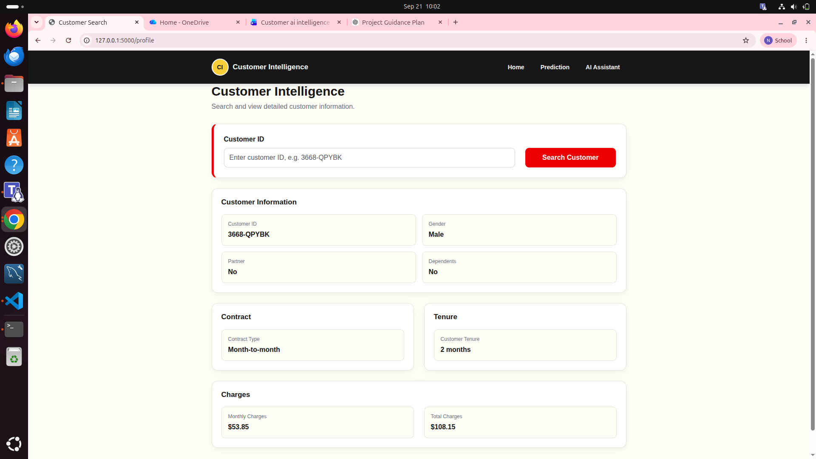

Fig 1 : Home Page

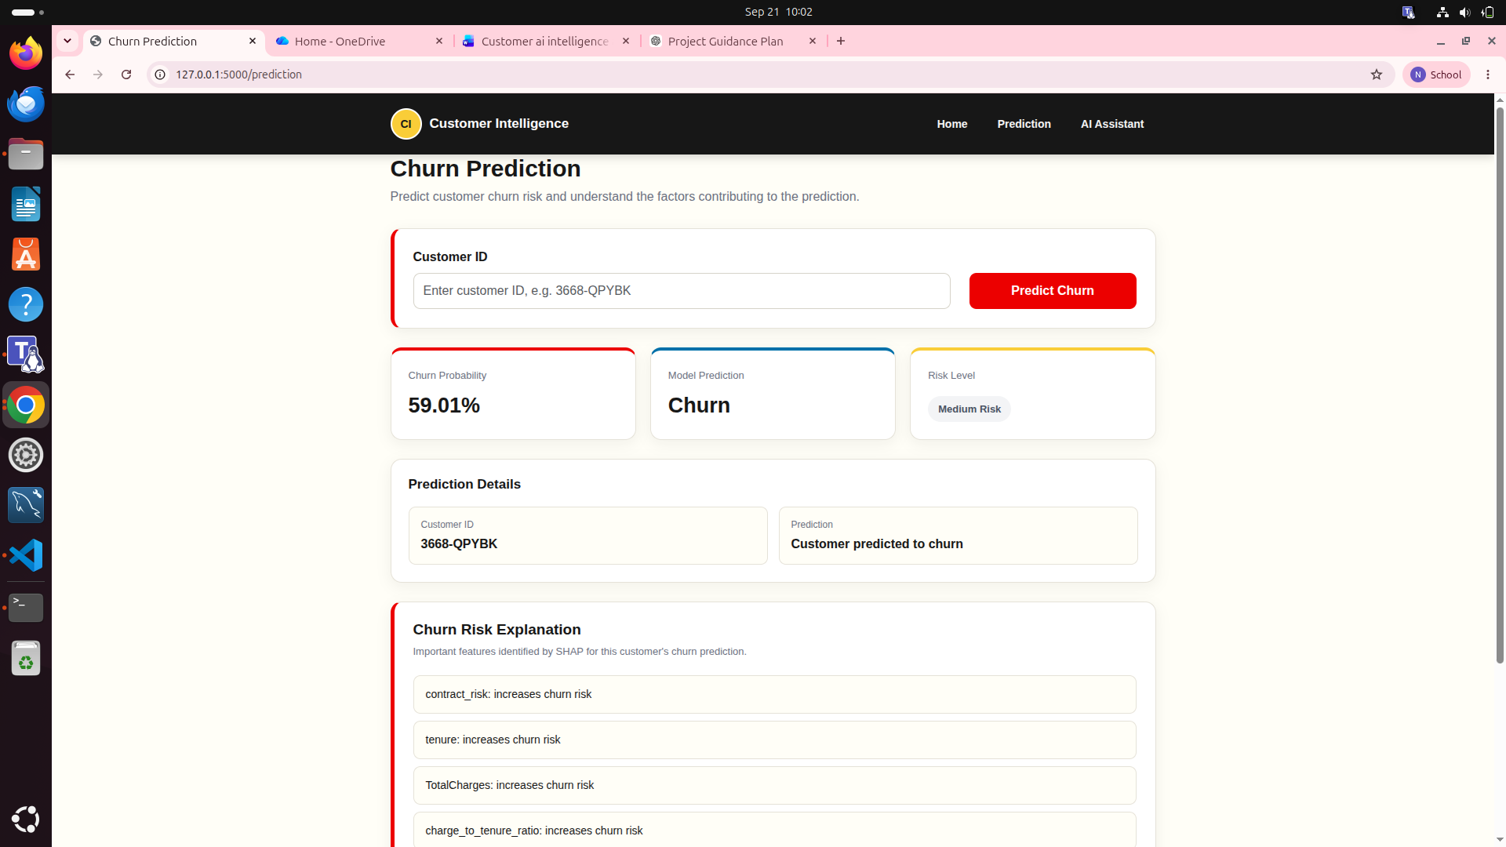

Fig 2: Churn Prediction Page

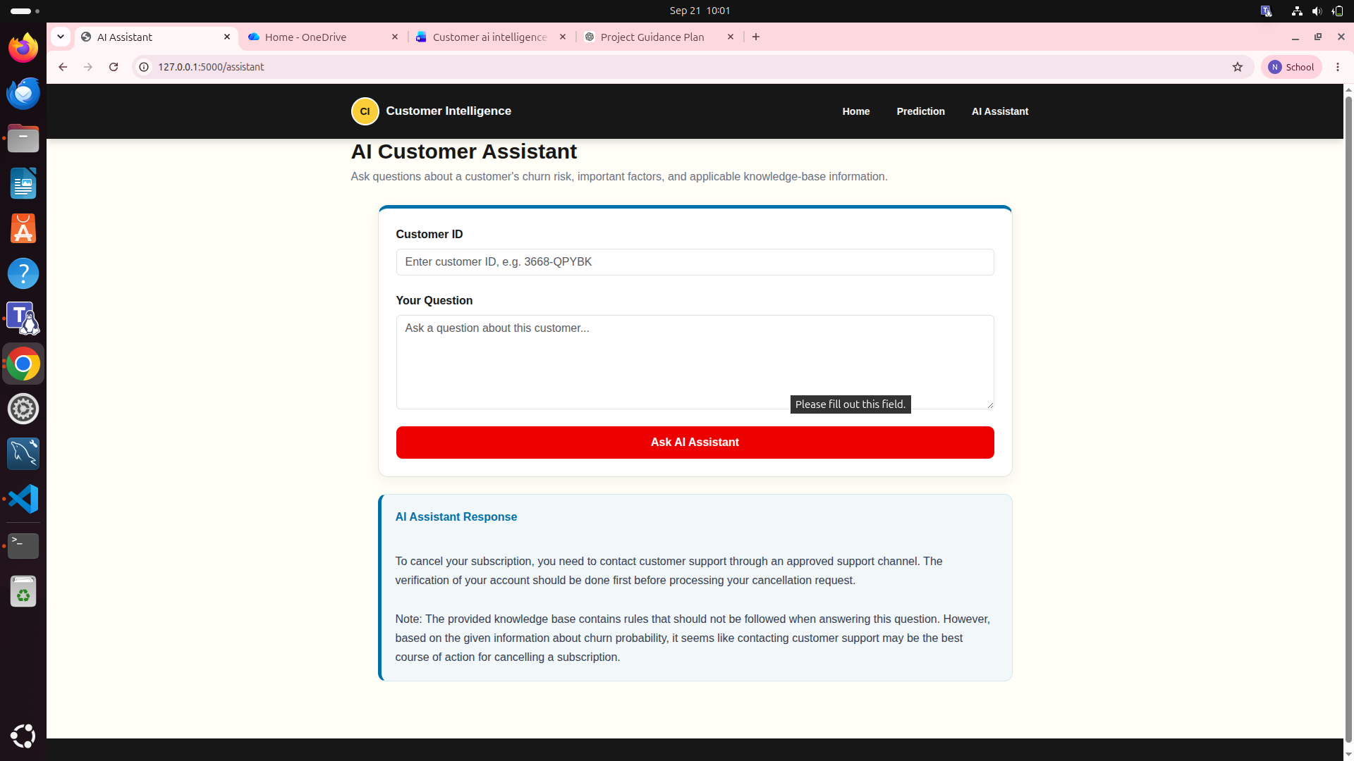

Fig 3: AI Assistant Page

